Web Development Lab (Assignment 1) - Submission
Campus Event Board - IIIT Vadodara

# Do this / How

1 Install Visual Studio Code

Download it free from code.visualstudio.com. This is where you will
write all your code. Install it with the default options.
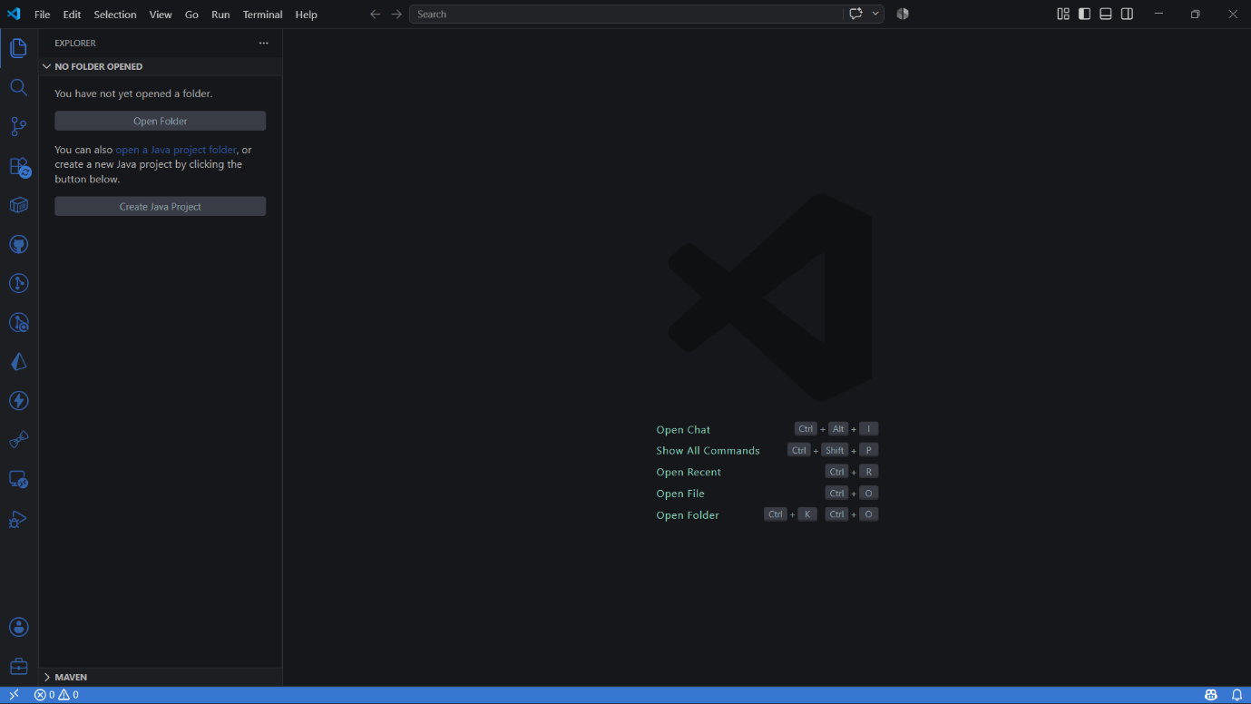

2 "Live Server" extension in VS Code

Right-click and "Open with Live Server". The page reloads
automatically every time you save.
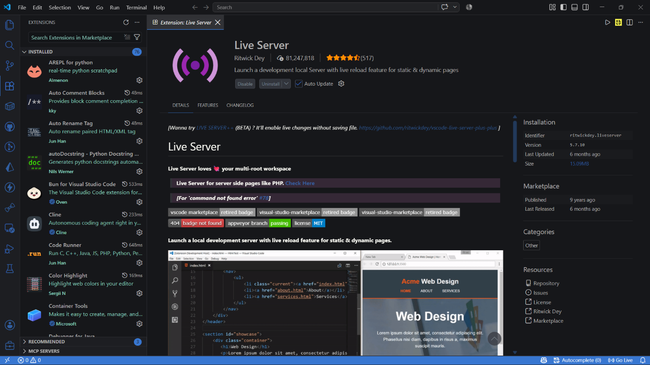
3 Make your project folder

Create a folder called event-board. Open this folder in VS Code with
File -> Open Folder.
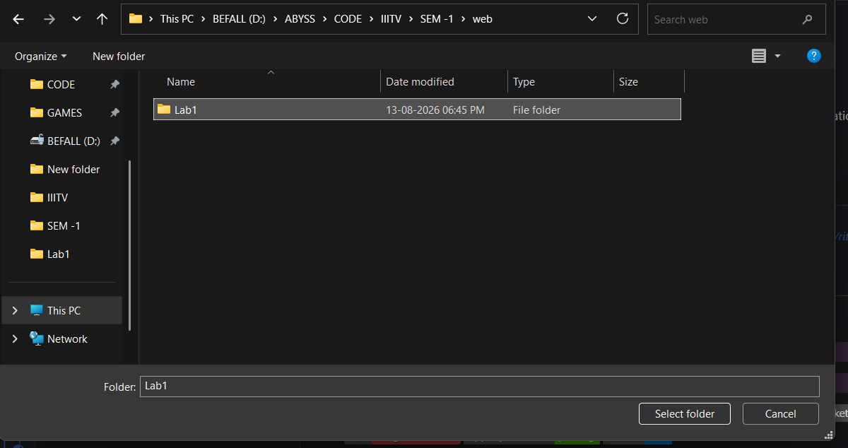
4 Create the home page file

Inside the folder, make a new file called index.html. The name index is
special - it is the page a site shows first.

5 Write a minimal page

Type a basic HTML page with a heading that says "Campus Event
Board". Include elements as per your wish. Save with Ctrl+S.
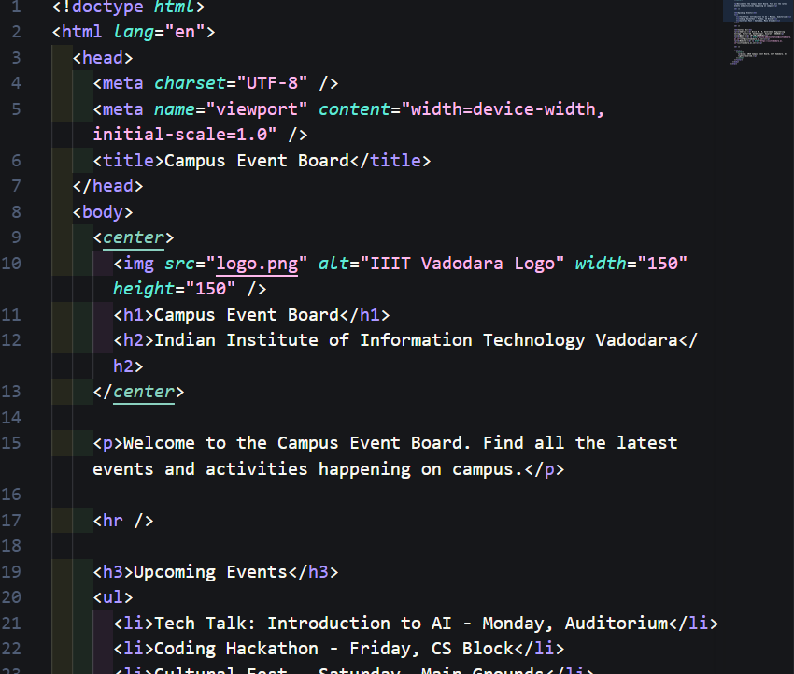

6 Open it in the browser

Double-click index.html in your folder, or drag it onto the browser
window. You should see your heading and sentence.

7 Look at what the browser received

Right-click the page and choose "View Page Source". This is the
exact HTML the browser read. Notice it is the text you wrote. 